**OP Analyzer**

Create a service which runs an analysis over specific data source.

Note that the application should be implemented step by step.

***Step 1***

Create an API which gets as a parameter “data source name”

And its output will be a list of items of type string.

For example: string[] Analyze(string datasourceName)

For this exercise use the following as data sources:

1. **Stackoverflow**When getting “Stackoverflow” as data source name the data will be fetch from the following API call which returns all highcharts stackoverflow queries:

<https://api.stackexchange.com/2.2/tags/highcharts/faq?site=stackoverflow>

From the returned data extract the titles of the returned items and return it as an outcome of the Analyze API.

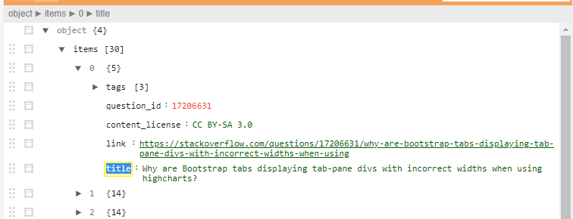

1. **Github**

When getting “Github” as data source name the data will be fetch from the following API call which returns commits in highcharts repository:

<https://api.github.com/repos/highcharts/highcharts/commits>

From the returned data extract the commits message return it as an outcome of the Analyze API.

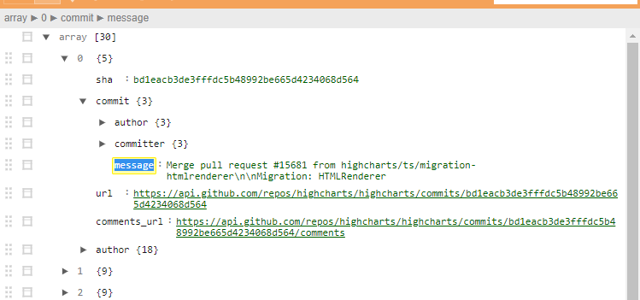

***Step 2***

Extend the API to get an Analysis flow id.

string[] Analyze(string datasourceName, long analysisFlowId)

An analysis flow is a predefined flow which can be ran over a specific data source.

An analysis flow should contain steps and execute the steps one by one.

For example:

Analysis flow {

Id: 1

Steps [

{Name: Remove short items,

Description: remove items which contains less than 5 characters}

{Name: Remove spaces,

Description: remove spaces from items}

]}

Eventually the API should –

a) run Step 1’s api, perform the flow and return the (in our example case – filtered) answer.